These are the 3 species of Iris flowers, for which we have 50 samples each.

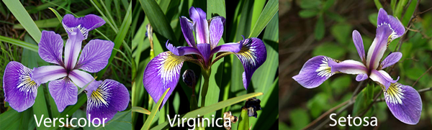

Source: <https://www.kaggle.com/anthonyhills/classifying-species-of-iris-flowers>

First, it’s important to get a good look at the Irish flower data set by calculating and visualizing different aspects of it.

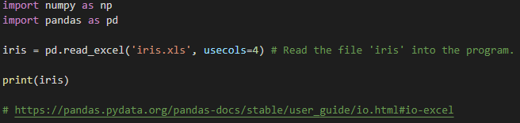

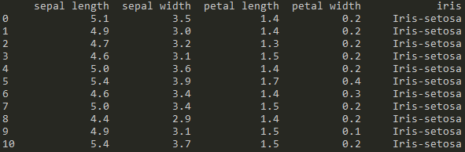

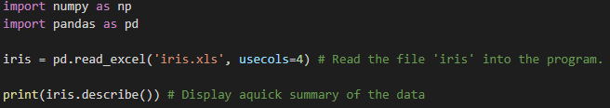

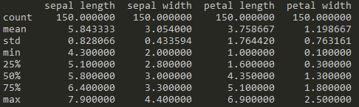

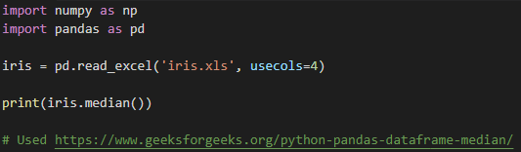

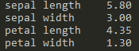

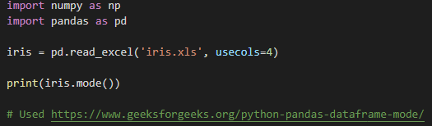



Now, we will separate between the different species:

Only display data of ‘Iris setosa’:

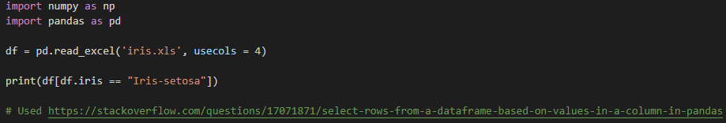

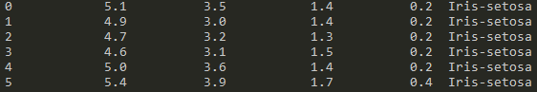

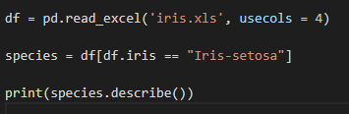

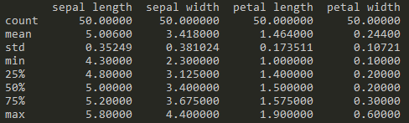

Setosa median:



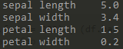

Setosa mode:

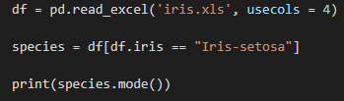



We do the same for the ‘Iris versicolor’:

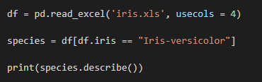

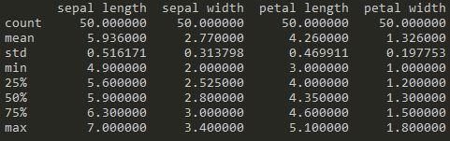

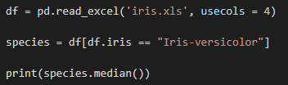

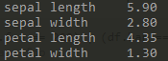

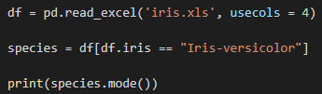



And with ‘Iris virginica’:

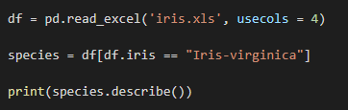

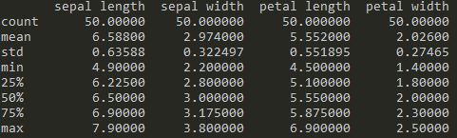

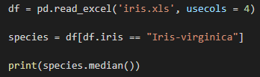



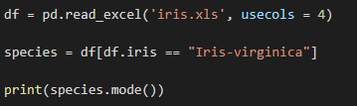



Histogram visualization of sepal length for all 3 species:

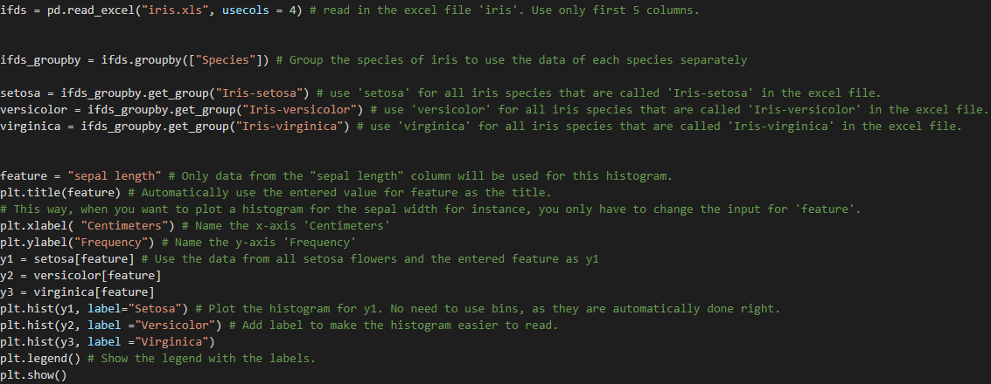

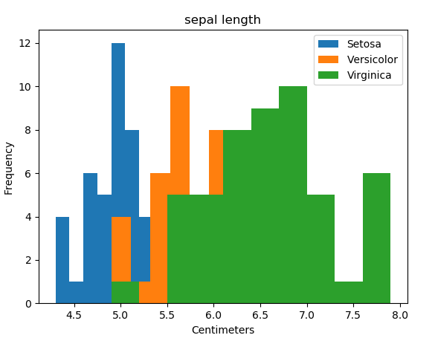

The code is similar for the other features, so I will just show the Histograms:

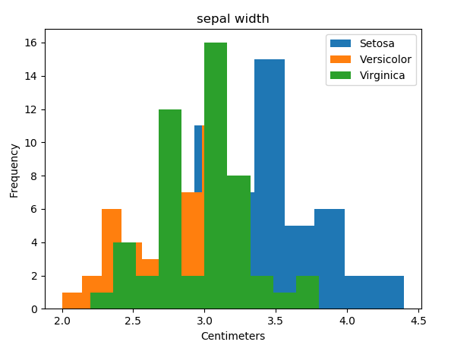

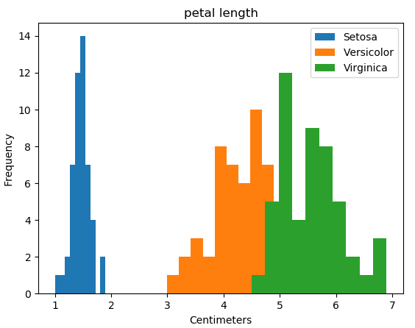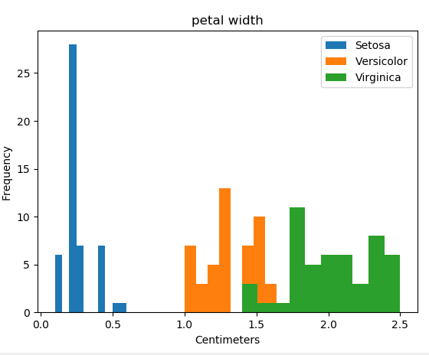

Visualization of sepal length:

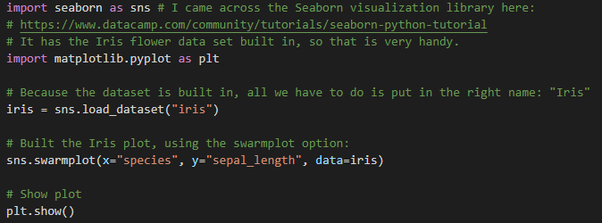

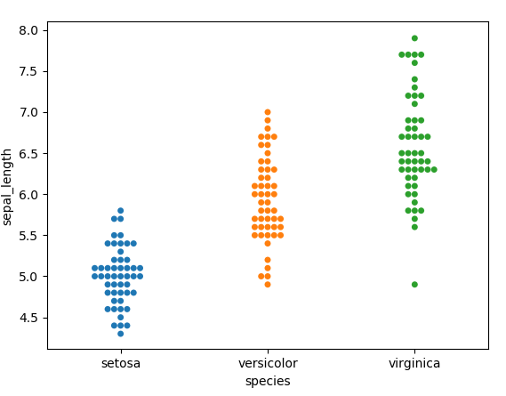

The swarmplot is the best option here in my opinion, as it tells you all you need to know in the blink of an eye.

We can do the same for: ‘sepal width’, ‘petal length’ and ‘petal width’.

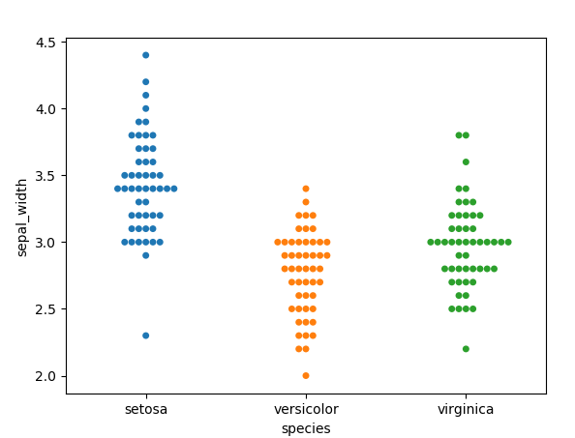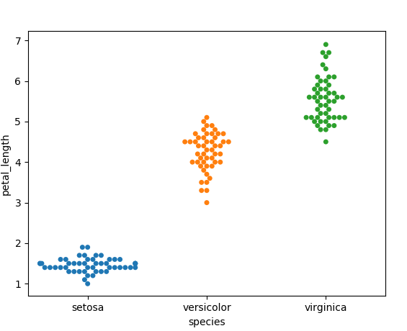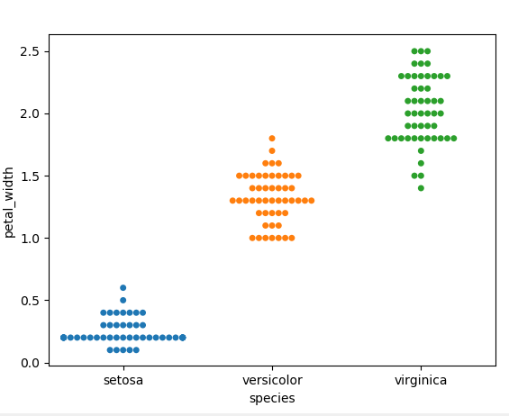

As you can see, iris setosa is easily distinguishable from versicolor and virginica, as the sepal length, and especially the petal length and width, is much smaller.

Now we will visualize possible relationships between the features. For instance, I want to know the ratio between the width and length of the sepals and petals of all species.

